Project_1

Part_1:

Creating resources on azure using terraform :

2 vms

One will be jenkins master

Other one will be ansible server(node)

Terraform script:

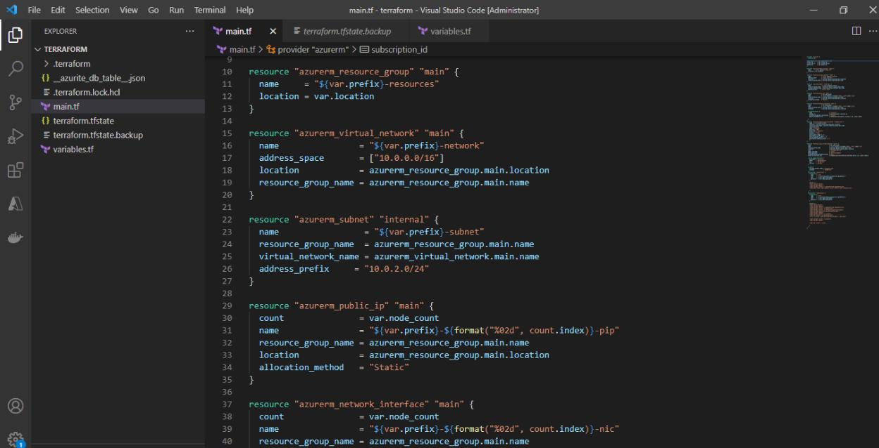

After running the script , resources(VMs) with installed software

created .

Mentioned below :

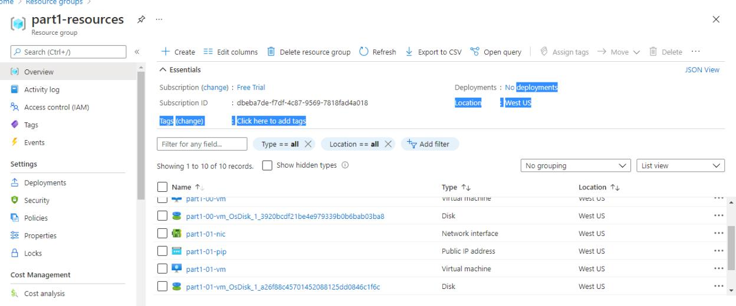

For vm0(jenkins master)



For vm1(node)

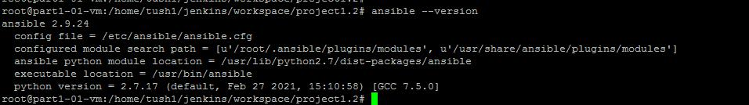

Others also on node1

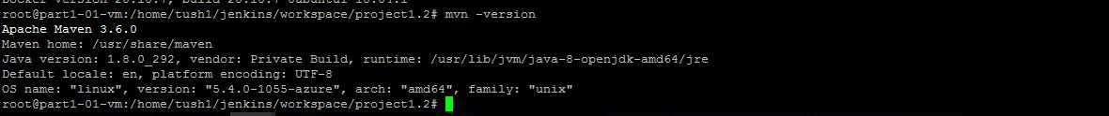

Jenkins is also installed ,below is the image for jenkins master getting configured.

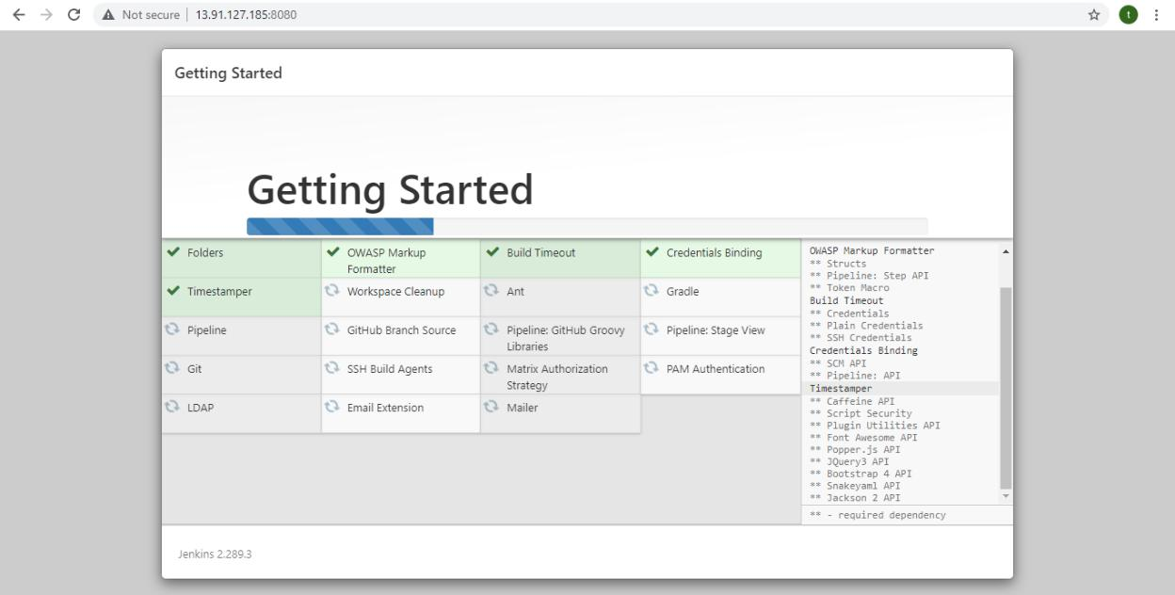

Part_2/3/4/5:

Webapp is created using eclipse and also dockerfile is created for that :

Below are the images for dockerfile and webapp:

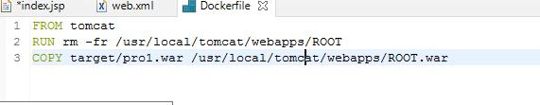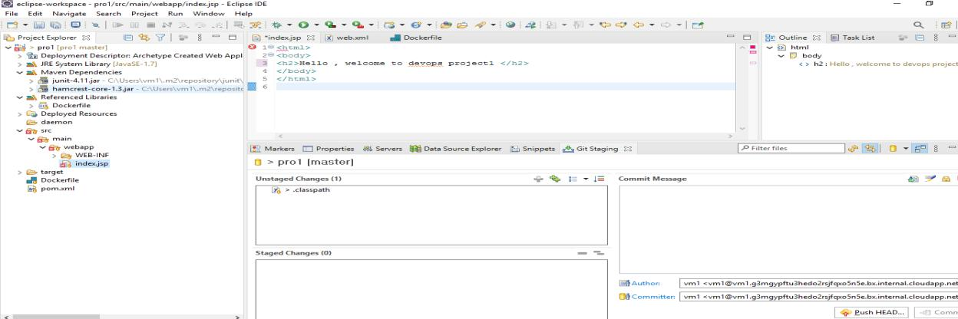

As github repository is created and project is pushed to that repository through eclipse. Repository url :

<https://github.com/Tushendra/techmproject1>

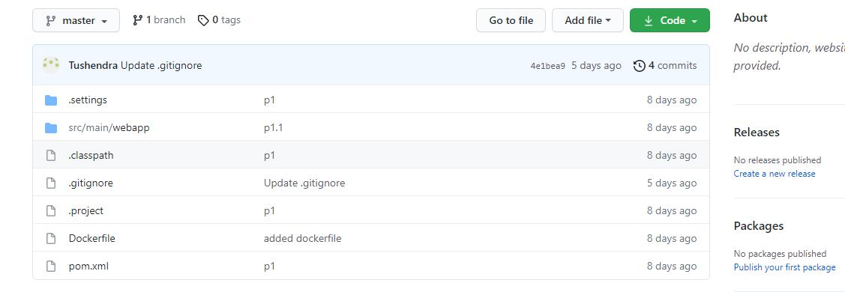

Part-7:

Project :1 pipeline is completed Pulling code from github

Building and packaging the code from dockerfile is also implemented

Pushed code to dockerhub successfully.

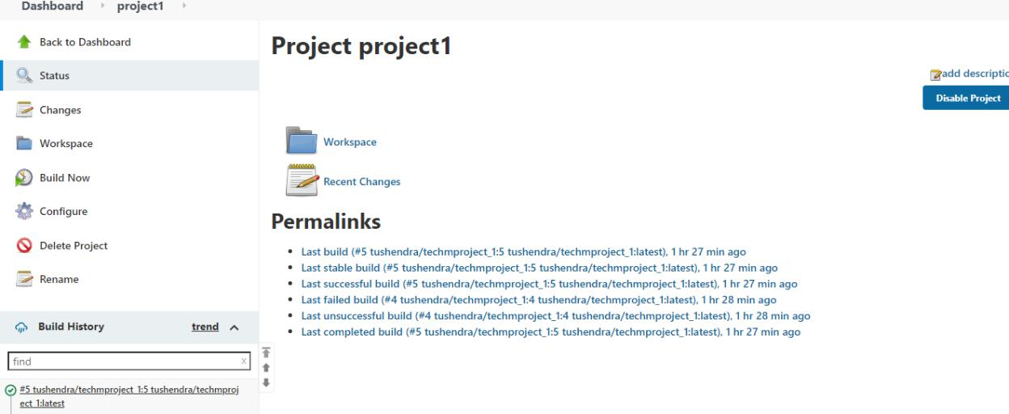

Image is pushed on dockerhub successfully

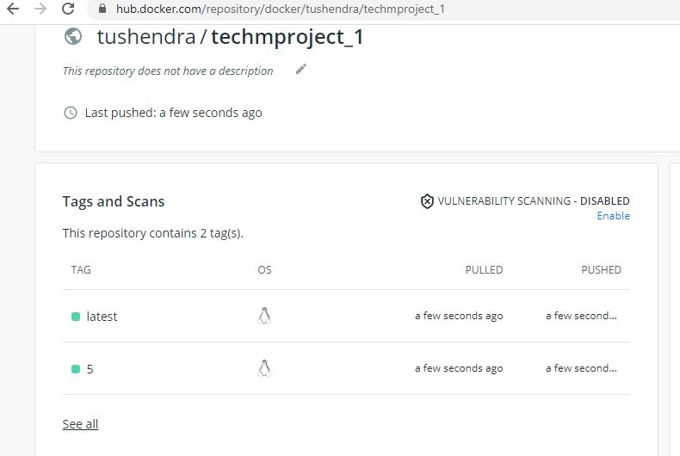

Now after running pipeline one Pipeline second needs to be run In which playbook will create a VM

Playbook will deploy docker on that created VM Freestyle job named as project 1.2

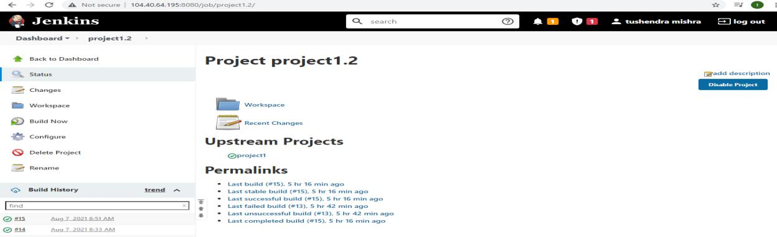

Now after above steps

Creating an application , pushing it to git , building and creating an image and publishing it on dockerhub , all these tasks are done by job1

Creating vm , installing docker on that vm from ansible is done by job2

Created webhook and configured in jenkins jobs for CI(contineous integration) Images are below :

In job1:

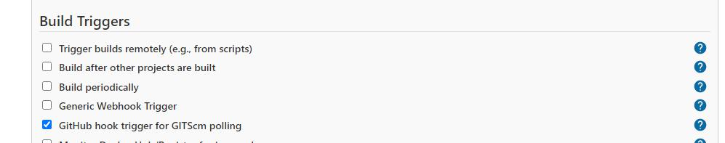

In job 2:

Build trigger is implemented:

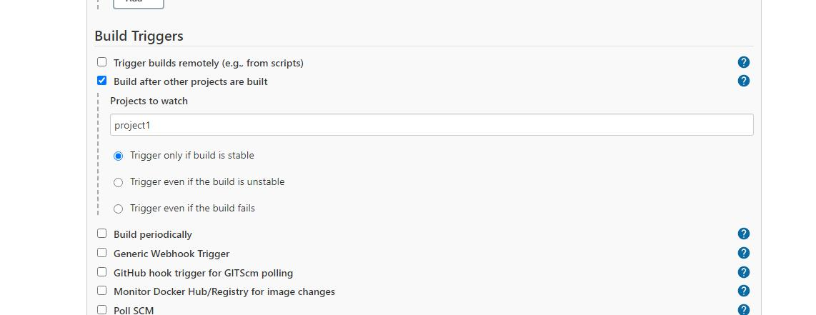

Then deploying is done .

After deploying

APPLICATION IS VISIBLE ON VM AT PORT 8080

SHOWN BELOW:

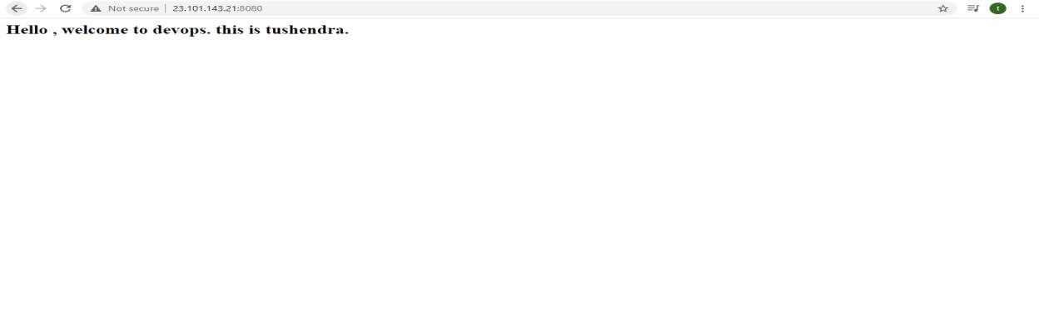

THANK YOU

PROJECT COMPLETED.